Contributors | Neil Teacher
Lesson Title | Listen and Hear |  |  |  | Version | 1 | Time | 40M
Semester | 2 | Grade/Age/Level | 1 | Textbook |  | Chinese Public School 2017
Week | 3 | Number of Sts. | 40+ | Unit & Module |  | 2 & 1
Topic | Hearing & Farm Animal Sounds
Target Language | Structure: What do you hear? I hear … + Farm animal sounds

Lesson Goals:
1.
Students to be able to identify and produce a variety of farm animal sounds.

2.
Students to use the structure ‘What do you hear? I hear a….

3.

Materials Needed
Computer
Whiteboard
USB
PPT
Blackboard
Chalk

Step (Presentation/Practice/ Production/ Review / Reward) | Actions | Anticipated Problems + Solutions | Time
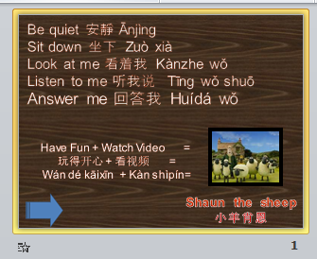  Warmer | Greet Students.  Go over class rules.  Play song or game from previous class as a review.  Put Students into teams based on their seating columns. | N / A | 5 min.
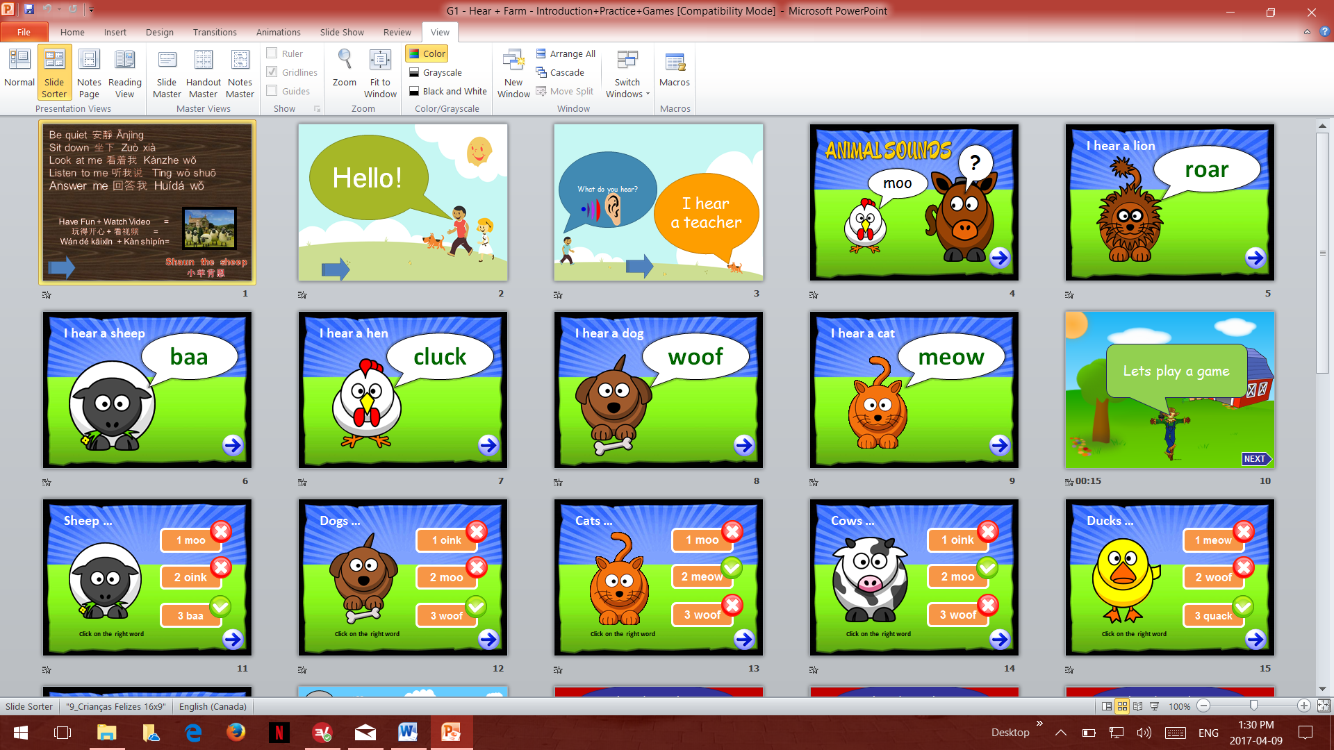  Presentation | Demonstrate then drill students to use the structure ‘I hear a …’  in response to the question ‘What do you hear?’ .  Have students then say the animal sounds with an accompanying animal action. Have students do the animal sounds and actions again in column teams, and award points based on participation. | Students miss the article ‘a’ in the sentence structure. Use fingers to illustrate each individual word as they are said.  I1 hear2 a3 hen4. | 10min
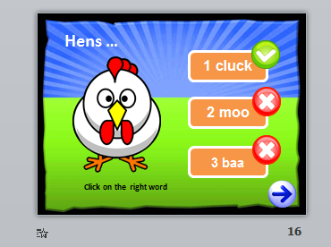  Practice | Play a word identifier game.  Have students listen to the animal sound and correctly identify which word represents that sound.  Award points based on participation and correct answers. | Some lower level students may have difficulties pronouncing the animal sound words, so numbers have been added to the options. | 2min
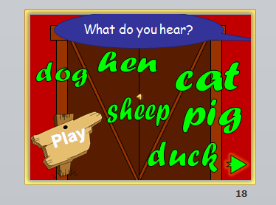  Practice | Play a sound identifier game.  Have students listen to the animal sound and correctly identify which animal makes that sound.  Award points based on participation and correct answers. | Students have previously learnt the names of the farm animals, so they shouldn’t have difficulty saying them. | 2min
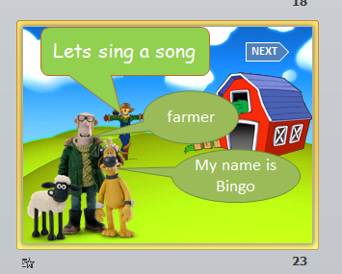  Practice | Play the video file (G1 - Hear + Farm - Song (1 min) B-I-N-G-O).  Play the song at least two twice.  First time, have students sing and perform actions to the song along with the teacher.  Second time, have students sing and perform actions, and award points based on participation. | Students have previously learnt the song in the book on page 9, so they shouldn’t have difficulty singing it. | 2min
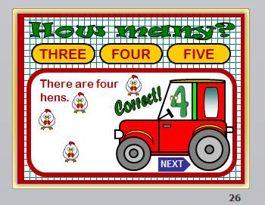  Practice | Play a number identifier game.  Have students correctly identify the right amount of animals on the slide.  Award points based on participation and correct answers. | Students have previously learnt numbers, so they shouldn’t have difficulty saying them. | 2min
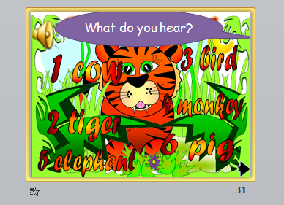  Practice | Play a sound identifier game.  Have students listen to the animal sound and correctly identify which animal makes that sound.  Make sure students use the  ‘I hear a…’ Structure.  Award points based on participation and correct answers. | Some lower level students may have difficulties pronouncing the animal words, so numbers have been added to the options. | 2min
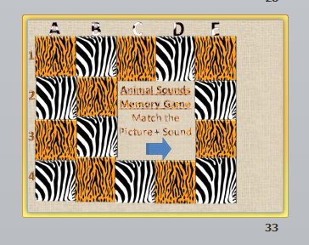  Practice | Play sound memory match game.  Demonstrate to the students that they have to match the animal sound with its animal word.  Say “C1 = bear word, and  C4 = bear sound”  Have students give two guesses to try and correctly identify matching animal words & sound squares.  Award points based correct answers. |  | 5min
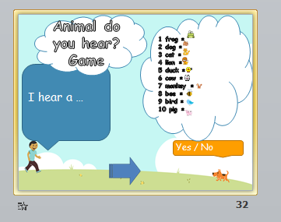  Review / Production | Using each individual animal on the slide; make an animal sound then demonstrate and drill students to use the structure ‘I hear a …’ with that animal word.  Have students individually come to the front of the class and make animal sounds, and have the other students correctly guess the animal. Award points based on participation and correct answers. |  | 5min
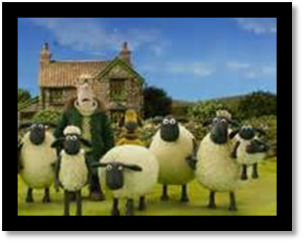  Reward | Tally the total points of each team and congratulate the team with the most points.  If the students have been well-behaved and have completed all the lesson ppt slides, they can be rewarded with a funny video. |  | 5min

